**Spatio-temporal analysis of mobility pattern during COVID-19 in NYC**

**Xiaoyi Wu**

**Introduction**

Since the World Health Organization declared the novel coronavirus (COVID-19) outbreak a global pandemic on 11th March in 2020, the disease has influenced every part of daily life and caused more than six million deaths globally (Johns Hopkins Coronavirus Resource Center, 2022). Mobility pattern tracks human movement behavior, which is critical to understand, evaluate and predict the pandemic transmission. Commuting and large-scale gathering aggravate pandemic transmission, while the onset of COVID-19 prevents social activity and lower travel behavior. Thus, many non-pharmacological policies such as quarantines, travel restriction, social distancing has been implemented by governments to prevent the spread of COVID-19.

As the most populous city in the United States with 8.8 million people distributed over 300.46 square miles (U.S Census Bureau, 2020), New York City has experienced widespread transmission and high infection rate since the first confirmed case on March 1st 2020. At the end of March 2020, NYC arrived a peak of COVID-19 and became the pandemic epicenter (Cordes & Castro, 2020) with a weekly mean of 5132 diagnosed cases and 1,566 hospital admissions. Identifying the spatio-temporal changes of human mobility pattern before, during and after the peak of COVID-19 is critical to analyze COVID-19’s impact on individuals. In addition, analyzing mobility changes in different contextual backgrounds suggests the heterogeneity of COVID-19’s impacts in different groups. For example, high-income individual may choose to decrease their visits to wholesale markets and restaurants and use takeaways services to buy necessary foods. However, people with low-/moderate incomes may have no choice but to leave home to buy food with higher risk of infection.

Therefore, this objective of this study is aimed to answer following question:

1. What are the most popular spots for people during COVID-19? How long people have stayed there? Where are they come from?
2. What are the spatio-temporal changes of mobility pattern during COVID-19?
3. How do the socio-economic factors influence people’s travel activities in different contexts?

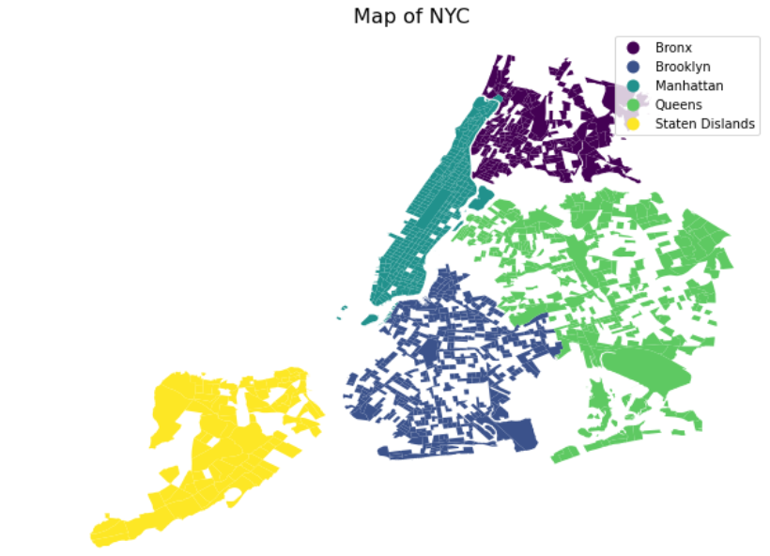

**Literature Review**

Existing studies typically examine the spatial distribution of mobility changes during a specific time. However, most work don’t take the temporal changing pattern into consideration from a long perspective and compare the spatial pattern before COVID-19. In addition, analyzing the changes with contextual factors such as race and income is also very important for the policy makers to reallocate resources efficiently and effectively. Thus, a more comprehensive study of mobility pattern change with social equity analysis over time is needed.

**Data**

The mobility information was provided by the pattern dataset and core places dataset from Safegraph. Safegraph is a data company that aggregates anonymized location data from third-party applications. Core place dataset are defined as any location humans can visit with the exception of single-family homes with 84717 point of interests (POI) in total, which encompasses a diverse set of places ranging from restaurants, grocery stores, and malls; to parks, hospitals, museums, offices, and industrial parks. Pattern dataset records the block-group-level mobility information such as visitor and visit counts to POI. However, this dataset does not cover all actual visitors but rather a subset of users that have smartphones and enabled their GPS information in various apps (Sevtsuk, 2021).

Socio-economic information such as race and income was from the American Community Survey (ACS) 2015-2019 5-year data

In addition, the geographic base map was from the US Census Bureau's TIGER 2020 Census Tracts (clipped to shoreline) data products.

Table 1: Data Source

|  |  |  |
| --- | --- | --- |
| Dataset | Geographic level | Source |
| Mobility Pattern in March 2019 | Block Group | Safegraph |
| Mobility Pattern in March 2020 |
| Mobility Pattern in March 2021 |
| Core Place | Block Group | Safegraph |
| Demographic Data e.g. median income, race | Census Tract | ACS 2019 5-year data |
| Geographic boundary | Census Tract | US Census Bureau |

**Methods**

Firstly, mobility pattern data were aggravated to the tract level. Then, the mobility index was constructed to represent the density of travel behavior on tract level. Combined with ACS 5-year data from U.S Census Bureau, we analyzed the mobility index in high-and low- income areas as well in white-majority and non-white majority areas.

**Analysis**

1. **Spatial analysis**

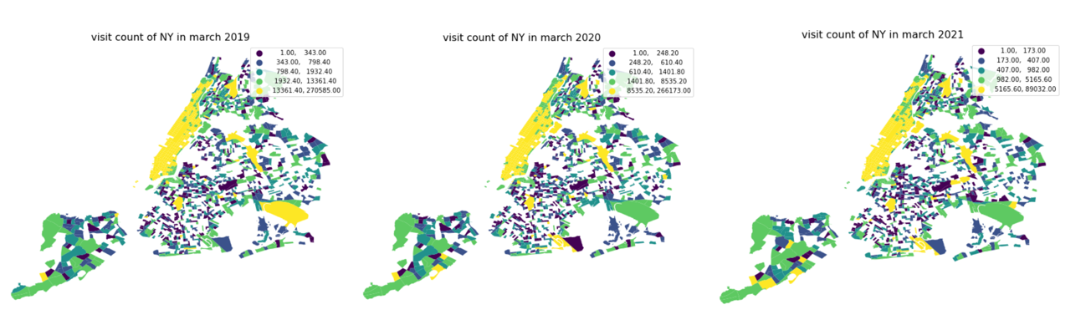Choropleth maps for the total visits in NYC shows that Manhattan, John F. Kennedy (JFK) International, LaGuardia Airport are the places people visit most often.

**The demographic of NYC is …**

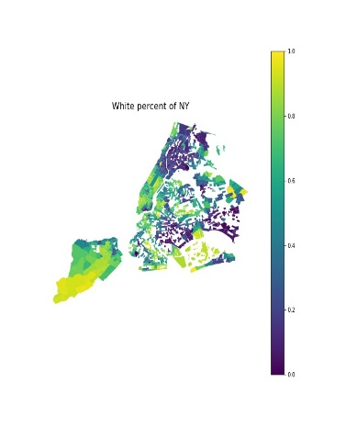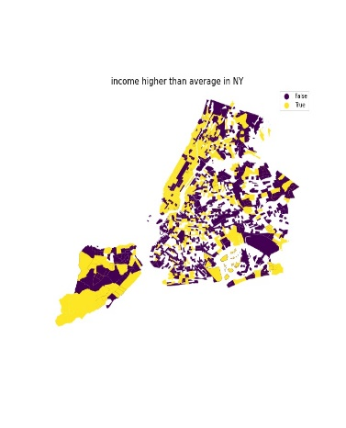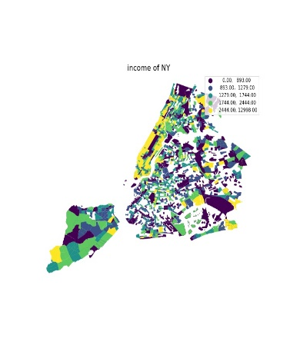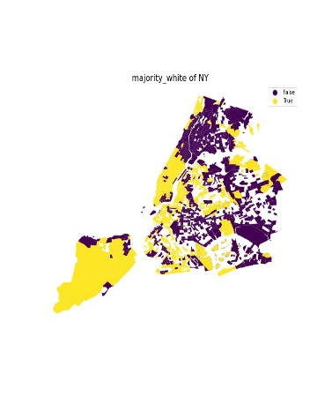

1. **Temporal analysis**

Visits to public places has decreased from 2019 to 2020 and 2021. Especially, visits to professional and business services, accommodation, food wholesale and retail places decreased more than 50% from 2019 to 2020. Decrease in visits to transportation and accommodation is continued to be higher 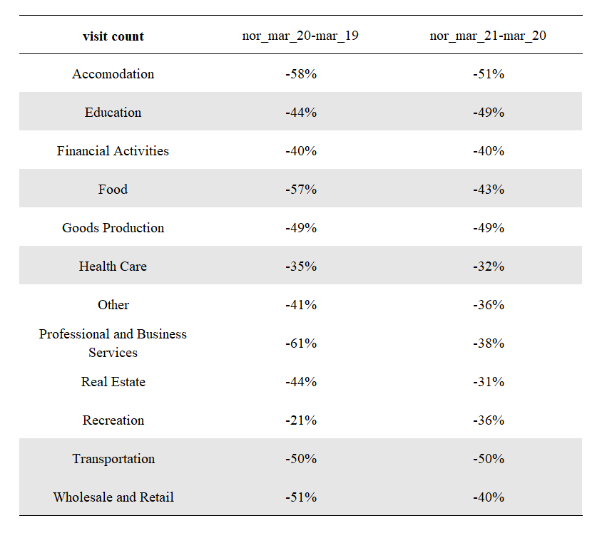than 50% from 2020 to 2021.

Table 1 Percent Change of visit count from 2019, 2020 to 2022

* 1. **Education**

The spatial distribution of change of visits to education shows that people decreased their visits to education from 2019 to 2020 and 2021 in general. Especially, we can see the clustering decreasing pattern in Manhattan.

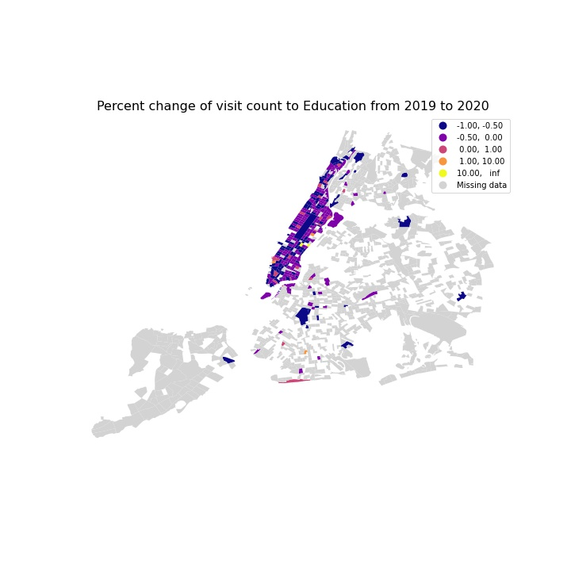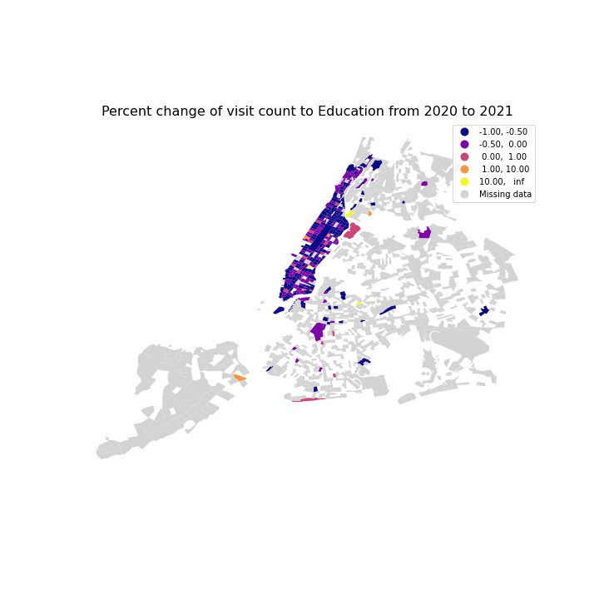

Percent Change of visit count to POI in education from 2019, 2020 to 2022

* 1. **Transportation**

1. **Contextual factor analysis**

Combined with the ACS demographic data, tracts in Staten Island and Manhattan with higher volume of visiting counts and visitor number tend to have higher income and white majority ratio than that of low visiting counts and visitor number. We think living expense in such places tend to be higher than other places, since the mid town and the lower town in Manhattan can provide more convenient services as the center of economy of the City. While the environment in Staten Island is more resident with beautiful nature landscape.

However, the tracts around JFK international airport with higher volume of visiting counts and visitor number tend to have less income and white majority ratio, since it is located at the suburb area and can’t provide convenient services.

As for the POI distribution, from the 2019 to 2020, POI counts in transportation has increased by 50 which is 40%; from 2021 to 2022, POI counts in transportation has decreased by 18 which is 30%. While POI counts in accommodation remain almost constant in different years.

Table 2 POI counts in different years

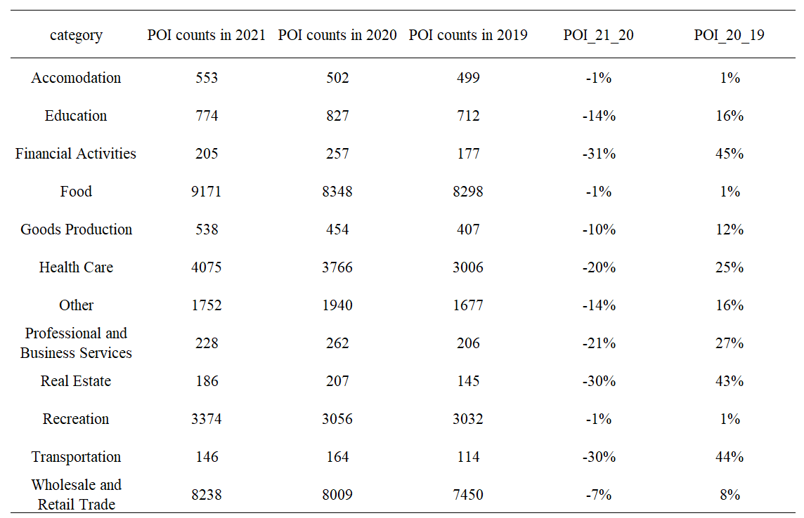

Transportations

From 2019 to 2020, people’s visits to John F Kennedy International Airport Terminal in Queen Borough increased from 1205 to 7180, which is 495.9%; at the same time, people’s visits to LaGuardia Airport increased from 23659 to 100413, which is 324.4%.

From 2020 to 2021, people’s visits to John F Kennedy International Airport Terminal in Queen Borough increased from 7180 to 84944, which is 1083.1%; however, people’s visits to LaGuardia Airport decreased from 100413to 71140, which is 29.2%.

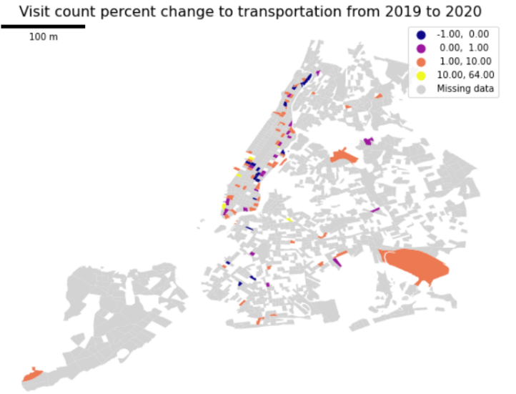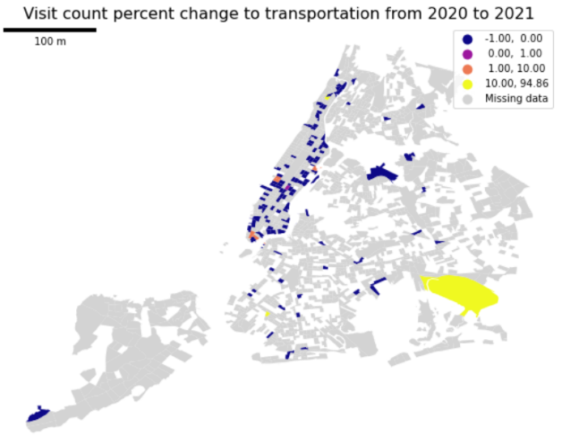

This study analyzes percent changes of visit count and median dwell time to different categories in Transportation.

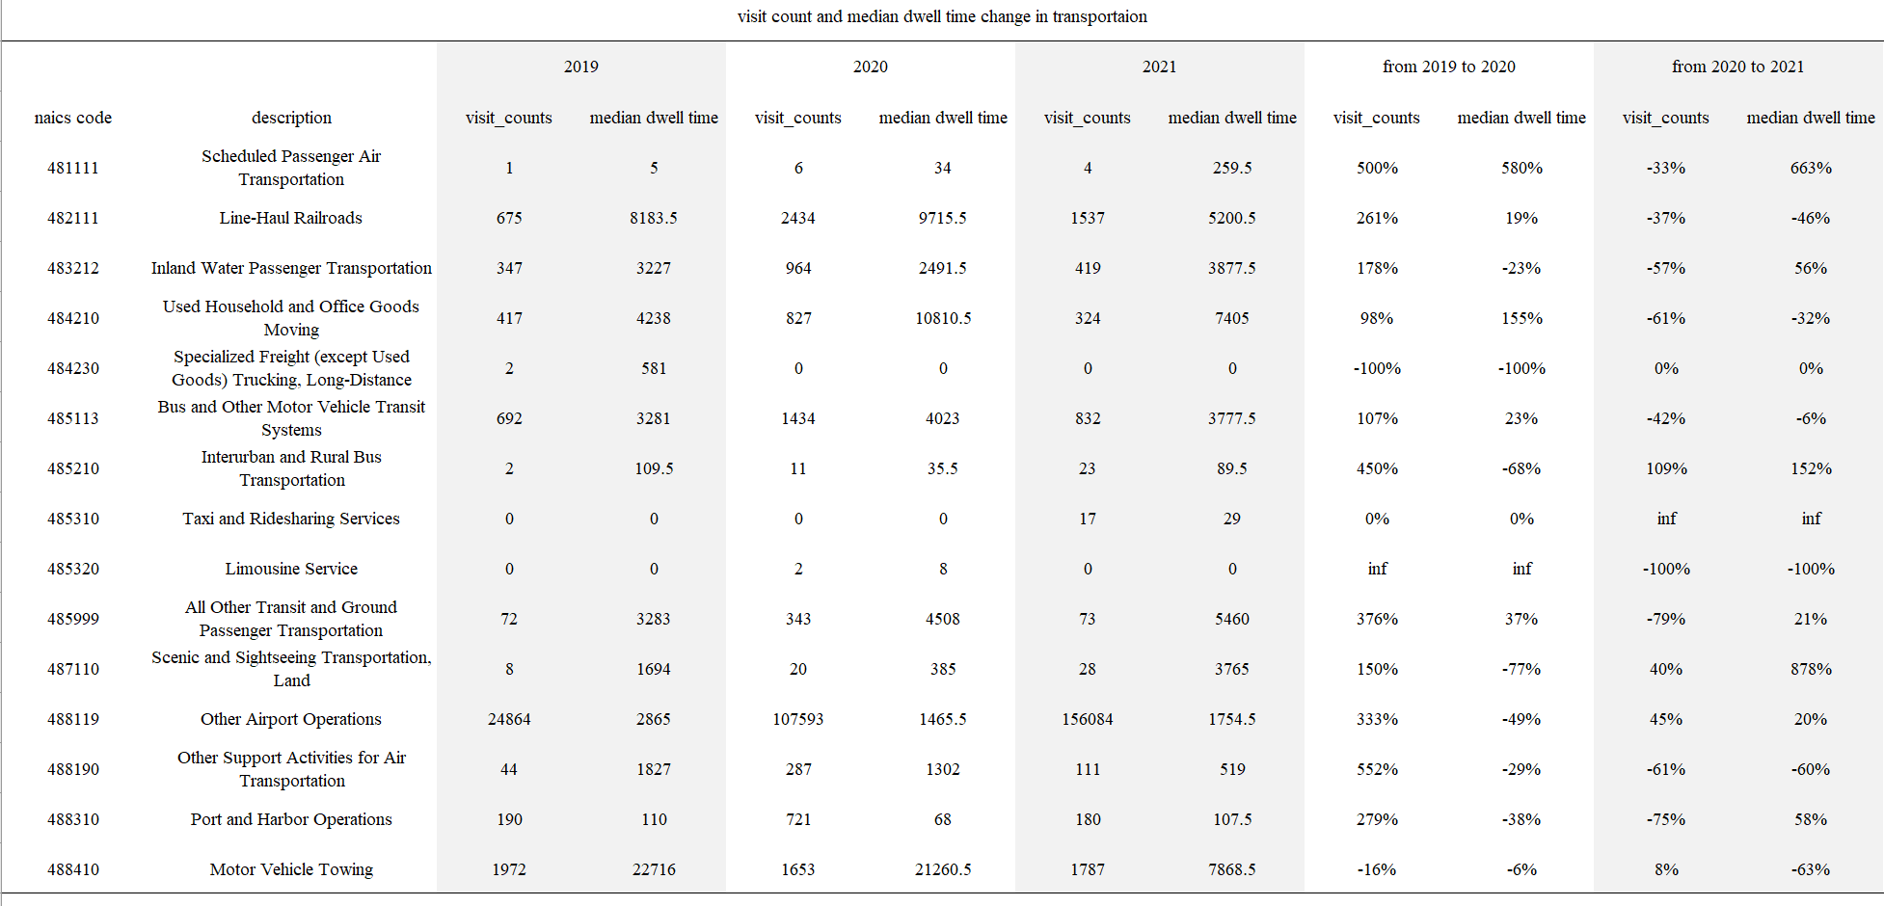

As for the visit count, from 2019 to 2020, people decreased activities in freight delivery and motor vehicle towing, however, they increased visits to air transportation, harbor port, airport, ground transit and harbor port twice. From 2020 to 2021, usage of interurban bus transportation and rural bus transportation has increased by over 109% and sightseeing transportation activities increased by 40%, while visits to other categories decrease in general.

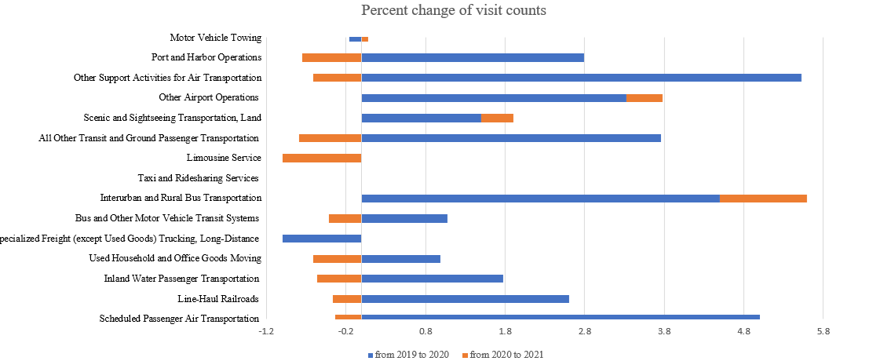

As for the dwell time, from 2019 to 2020, people increased their dwell time in airport most by 580%, and time in goods moving place by 155%. Dwell time in ground transit is increased slightly by 37%. As for the dwell time in trucking and scenic transportation have decreased most by 100% and 77% accordingly. From 2020 to 2021, people increased their dwell time in scenic and sighting seeing transportation and airport most by 877.7% and 633.3% accordingly. Time in interurban and rural bus transportation also increased by 152.1%. However, time spent at limousine services has decreased by 100%.

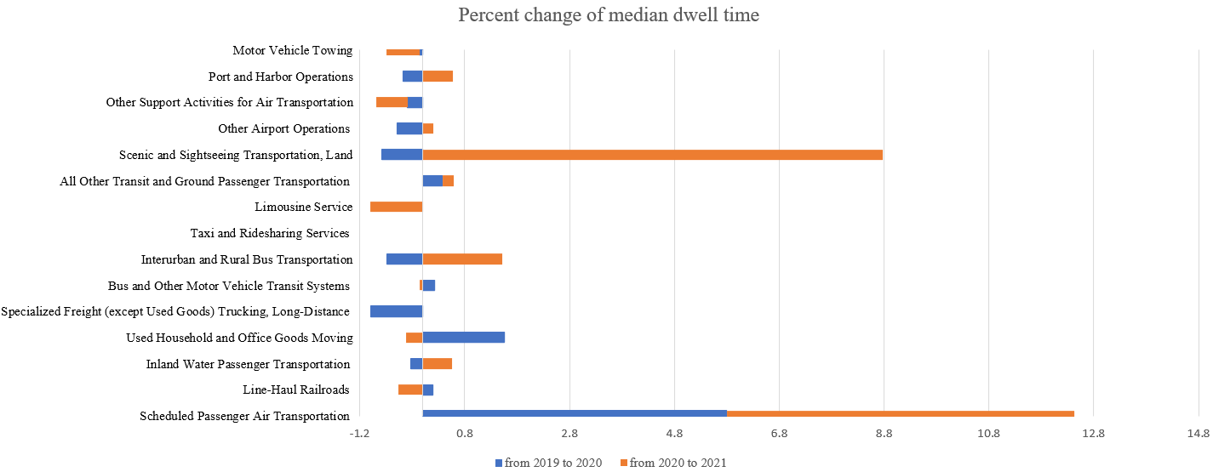

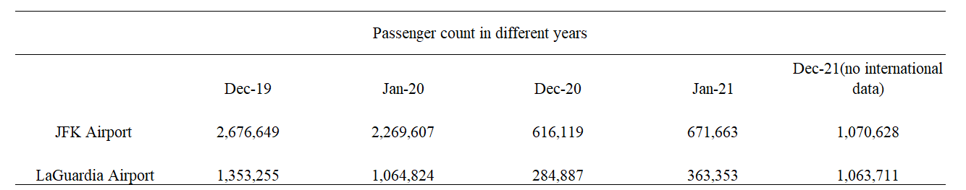

However, further analysis about correlation between demographic factors and mobility pattern and spatial autocorrelation need to be implemented.

**Literature**

[1] Cordes, J., & Castro, M. C. (2020). Spatial analysis of COVID-19 clusters and contextual factors in New York City. Spatial and Spatio-temporal Epidemiology, 34, 100355.

[2] <https://coronavirus.jhu.edu/map.html>

[3] https://www1.nyc.gov/site/planning/data-maps/open-data/census-download-metadata.page